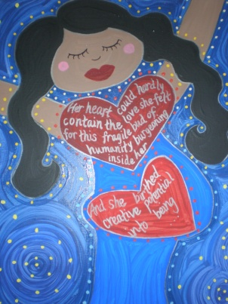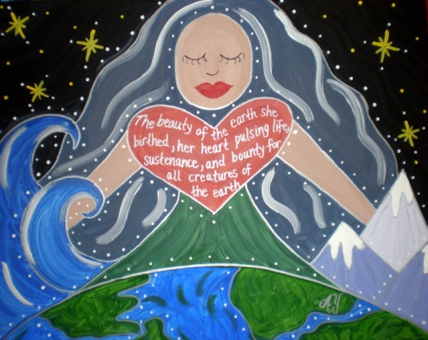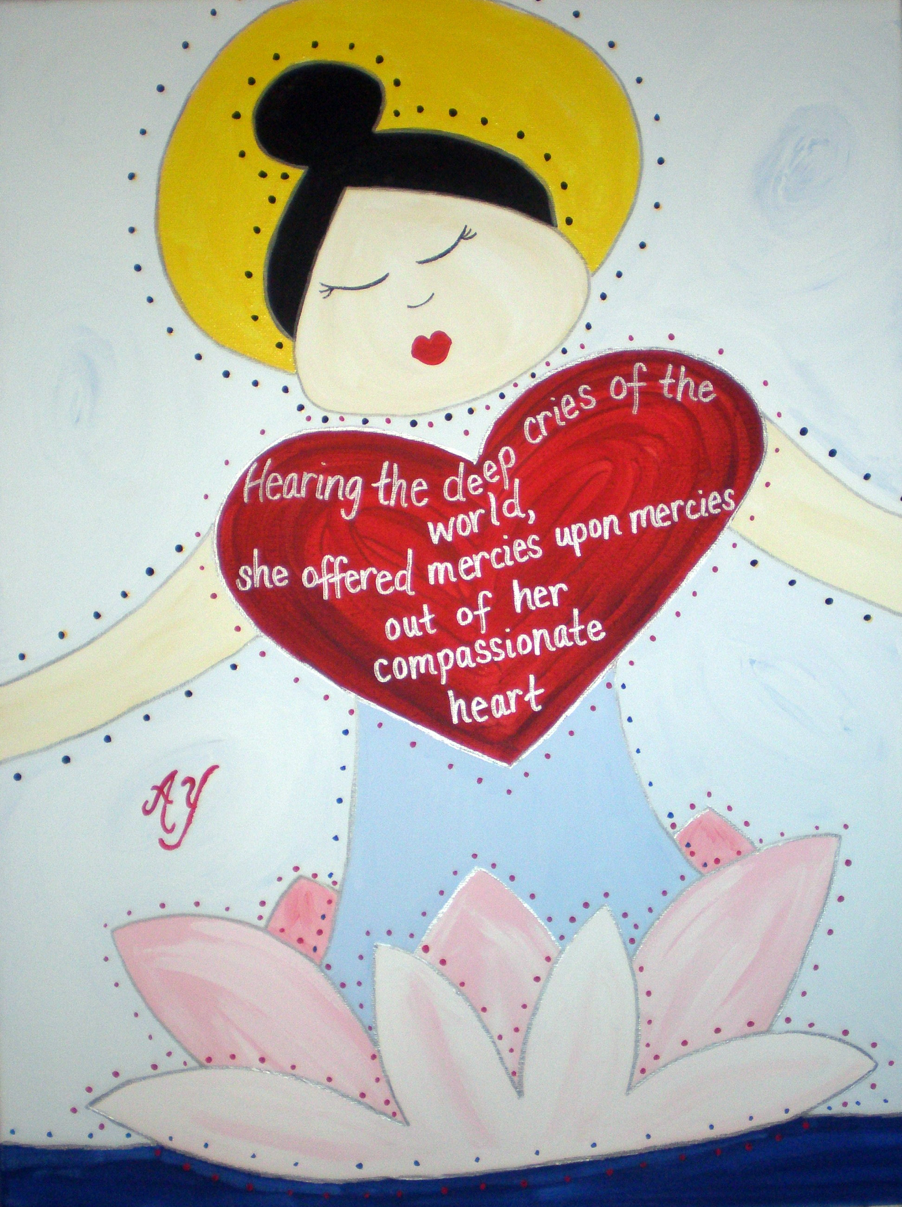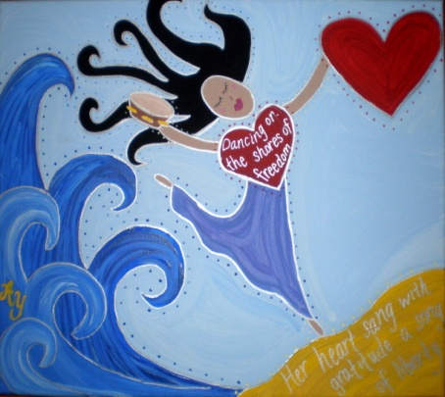

Holy Women Icons

Books, Paintings, Cards, Lectures, Sermons, and Retreats by
Rev. Dr. Angela Yarber
Artist. Scholar. Minister. Author. Activist.
www.angelayarber.com

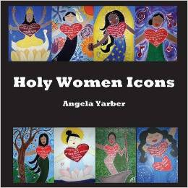
Holy Women Icons gives traditional iconography a folk feminist twist. The icons have toured the country in galleries, churches, seminaries, and LGBTQ Centers. The book, Holy Women Icons, features nearly 50 color images of the icons with an essay describing each woman portrayed. Holy Women Icons is more than an art show and book; it is a movement that seeks to empower and inspire women and LGBTQ persons through:

- Retreats, Workshops & Conferences
- Sermons
- Lectures & Speaking
- Book Signings & Readings
- Traveling Exhibitions
- Sales of Icons, Prints, Cards & Books
- Commissioned Icons

To arrange an event for your gallery, church, Women’s or LGBTQ Center, seminary, or university, contact Rev. Dr. Angela Yarber at yarberam@wfu.edu

